**Pizzas Sales Report**

**A.KPI’s**

**1**. **Total Revenue:**

SELECT SUM(total_price) AS Total_Revenue FROM pizza_sales

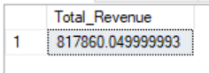

**2. Average Order Value:**

SELECT SUM(total_price) / COUNT(DISTINCT order_id) AS AVG_Order_Value FROM pizza_sales

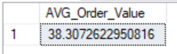

3. **Total Pizzas Sold:**

SELECT SUM(quantity) AS Total_Pizzas_Sold FROM pizza_sales

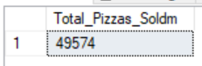

4. **Total Orders:**

SELECT COUNT(DISTINCT order_id) AS Total_Orders FROM pizza_sales

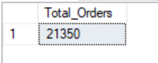

5. **Average Pizzas Per Order:**

SELECT CAST(CAST(SUM(quantity) AS DECIMAL(10,2))/CAST(COUNT(Distinct order_id) AS DECIMAL(10,2)) AS DECIMAL (10,2)) AS AVG_Pizzas_Per_Orders from pizza_sales

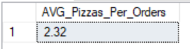

**B. Daily Trend for Total Orders**

SELECT DATENAME(DW, order_date) AS Order_Day, COUNT(DISTINCT order_id) AS Total_Orders

FROM pizza_sales

GROUP BY DATENAME(DW, order_date)

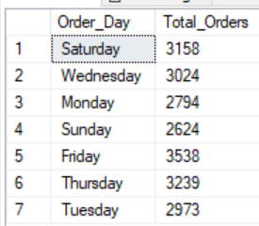

**C. Monthly Trend for Orders**

SELECT DATENAME(MONTH, order_date) AS Order_Day, COUNT(DISTINCT order_id) AS Total_Orders

FROM pizza_sales

GROUP BY DATENAME(MONTH, order_date)

ORDER BY Total_Orders DESC

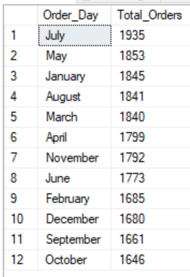

**D. % of Sales by Pizza Category**

SELECT pizza_category, SUM(total_price) as Total_Sales ,SUM(total_price) * 100 / (Select SUM (total_price) FROM pizza_sales) AS PCT

FROM pizza_sales

GROUP BY pizza_category

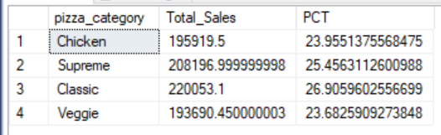

**E. % of Sales by Pizza Size**

SELECT pizza_size, CAST(SUM(total_price) AS DECIMAL(10,2)) as Total_Sales ,CAST(SUM(total_price) * 100 / (Select SUM (total_price) FROM pizza_sales) AS DECIMAL(10, 2)) AS PCT

FROM pizza_sales

GROUP BY pizza_size

ORDER BY PCT DESC

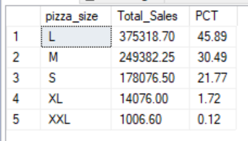

**F. Total Pizzas Sold by Pizza Category**

SELECT pizza_category, SUM(quantity) as Total_Quantity_Sold

FROM pizza_sales

WHERE MONTH(order_date) = 2

GROUP BY pizza_category

ORDER BY Total_Quantity_Sold DESC

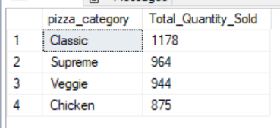

**G. Top 5 Pizzas by Revenue**

SELECT Top 5 pizza_name, SUM(total_price) AS Total_Revenue

FROM pizza_sales

GROUP BY pizza_name

ORDER BY Total_Revenue DESC

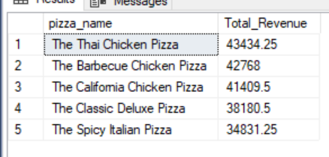

**H. Bottom 5 Pizzas by Revenue**

SELECT Top 5 pizza_name, SUM(total_price) AS Total_Revenue

FROM pizza_sales

GROUP BY pizza_name

ORDER BY Total_Revenue ASC

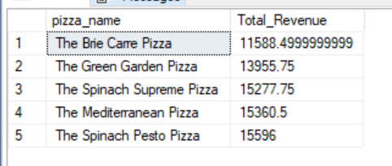

**I. Top 5 Pizzas by Quantity**

SELECT Top 5 pizza_name, SUM(quantity) AS Total_Pizza_Sold

FROM pizza_sales

GROUP BY pizza_name

ORDER BY Total_Pizza_Sold DESC

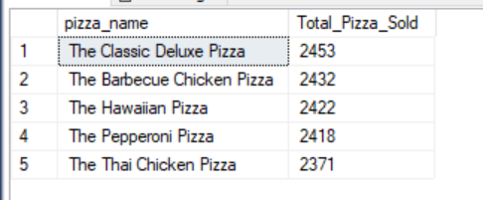

**J. Bottom 5 Pizzas by Quantity**

SELECT TOP 5 pizza_name, SUM(quantity) AS Total_Pizza_Sold

FROM pizza_sales

GROUP BY pizza_name

ORDER BY Total_Pizza_Sold ASC

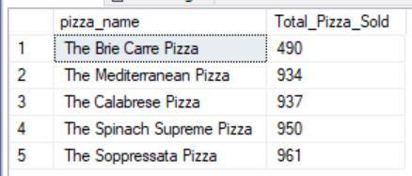

**K. Top 5 Pizzas by Total Orders**

SELECT Top 5 pizza_name, COUNT(DISTINCT order_id) AS Total_Orders

FROM pizza_sales

GROUP BY pizza_name

ORDER BY Total_Orders DESC

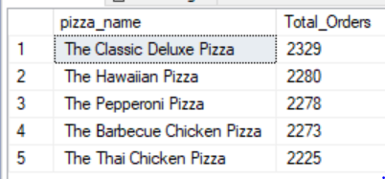

**L. Borrom 5 Pizzas by Total Orders**

SELECT Top 5 pizza_name, COUNT(DISTINCT order_id) AS Total_Orders

FROM pizza_sales

GROUP BY pizza_name

ORDER BY Total_Orders ASC

